Design of Low Cost Humanoid Robot for Serving Application
Abstract:
The robot is a very common name in this era, as it is used in our day-to-day lives for various applications, from room cleaning to lifting heavy goods. Robots are a mixture of electrical and mechanical components to carry out the tasks programmed. In this article, a low-cost humanoid robot is developed using the 3D printing method. In this robot, some of the tasks that have to be performed by the robot are line following, voice assistance, and serving up to 500-gram-weight components. This robot is built with wireless and battery systems so that it can perform the task from a distance and use various commands preprogrammed in the system.
Keywords: Humanoid, Serving robot, Line follower, Voice assistance robot

Introduction:
Robots are a common phenomenon these days, as they can be seen in factories, workshops and even in the house on a small scale. Like in the industry, there are various applications, like welding operations, where a high amount of precision is required. In the semiconductor industry, the manufacturing of PCB boards and processors takes place at a precision level of nanometers. In this article, the humanoid robot has a full body and is manufactured at a low cost with high precision so that the overall cost of the robot can be brought down as much as possible. Its versatility allows it to be used in multiple domains.
In this PLA material (for 3D printing), steel, FRP is used to manufacture various parts. The Robot head is manufactured with PLA material using Additive manufacturing; the upper half of the body is manufactured using polymer composites; the lower half is manufactured using MS 16 gauge square tubes; and is covered with sun board for aesthetic looks.

3D printing is an additive manufacturing technique used for the manufacturing of precision work. Where all the parts are designed in the CAD software, later manufacturing components are done in the 3D printing machine
Many research papers have shown the work of great researchers on the field of humanoid robots and their application in various industries. Especially the work of Jennifer Wang [1] was very inspiring and also the work by Kittiwad kanthrak et al [2] was very motivating. In their paper they have explained about the various problems encountered while making a humanoid robot.
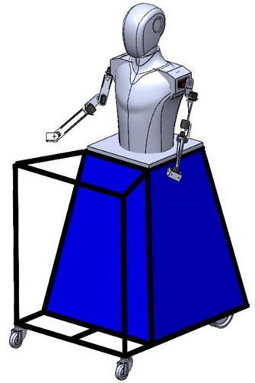
CAD model of Robot
There are many environmental conditions where a normal human cannot work is in a risk to work at in such scenarios a humanoid robot is a must to complete the task. With the rise in research and technology we can constantly upgrade and improvise the current model of the robot by increasing the precision and accuracy of the robot movement to the smallest unit possible. Although there is a considerable amount of work to be done in the field of robotics it is growing exponentially. Humanoid robots resemble human appearance hence the name so there are parts which can be made to even have the same function ,such as having eyes for vision and recognition, ears for listening, mouth for speech arm for task manipulation etc.
Humanoid robots can be taught cognitive abilities by studying how human move and interact with the surrounding and the data can be programmed into an algorithm for the robot. It can mimic how a person would respond to certain scenarios or situations and can even express emotions like a human. Further this can be used to develop computational models of human behaviour.

Literature Survey:
Kruthika K et al [3]- This paper presents the development of 5 DOF robotic arms for feeding elderly and disabled people. The arm is controlled through GUI inputs. The principle used is the kinematics of the robot and MATLAB. Forward kinematics was used to position and orientation of an end effector. Proteus, Arduino IDE, and processing were used to test the functionality of the arm. The use of Arduino MEGA2560 I/O board, potentiometers, DC motors, and force sensors are used to enhance the functionality
Prakash K R et al [4]- In this paper presents the development of humanoids for indoor applications focusing on medical tasks. It utilized 3D printing for cost effective parts and Arduino uno for control for service tasks. It has arm moments with Arduino uno control to deliver needed medicines. Head parts are 3D printed with ABS plastic and joined with the help of nuts and bolts
Parul Gupta, Vinith Tirth and R.K Srivastava, "Futuristic Humanoid Robots: An Overview" In this paper they reviewed successes and failures in the field where humanoid research began. Further, an extrapolation of recent developments is also given where it may take us in the future
Objectives:
- To build cost-effective humanoid serving robots, using 3D printing and cost-effective materials
- To serve various features like Face detection, Face tracking, obstacle avoidance, Line following, Text-to-speech, etc.
- The robot should work and integrate with suitable modes like online and offline and devices
- The robots should be working on wireless machines that can be operated in various terrains.

Fabrication:
The fabrication of the robot involves various steps which is put into a flowchart below for easy understanding.
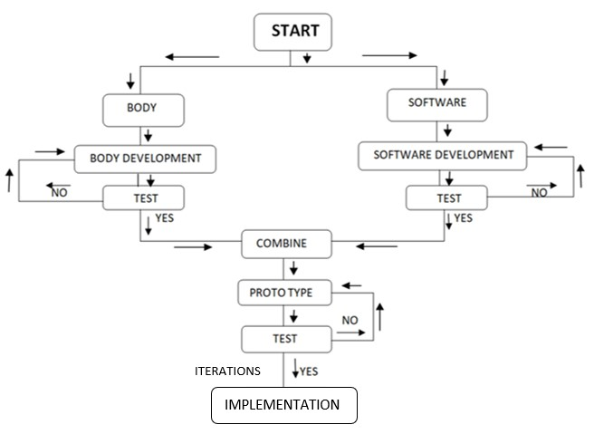

Developing a robot involves various disciplines such as electro-mechanics devices and software for operations. To ensure efficient design, construction, and implementation, the development method of the robot is divided into two parts as discussed below.
1. Body development
2. Software development

Body Development:
The body's development flow is from the design of the body to test/implementation which includes the head to the base with the wheel motion system
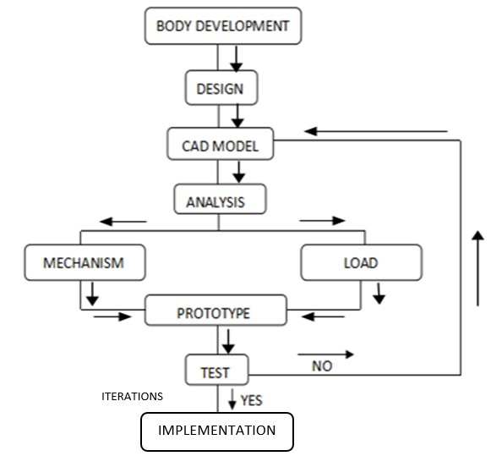
Firstly, the head part is considered which 3D printed and fixed with nuts and bolts is. It includes an eye mechanism and the neck part has a rotation controlled by servomotors. The torso [mid part] of the robot is made of fiber using FRP. It has arms with 5 degrees of freedom and a gripper mechanism to pick an object and provide service. The lower half of the body is designed with an extension in such a way that it is helpful to carry the objects easily on it. The lower frame is made up of mild steel and covered with wood which has a trapezoidal look. The total lower half and upper half of the body stand on the strong base which is the four-wheeled system with motors providing motion and electronics providing the power. The mentioned mechanisms are tested and if iterations are needed then done and again tested
3D printing:
It is also known as additive manufacturing, where a three-dimensional object is created using CAD model. It tremendously gained importance in the engineering field because of its high benefits. It provides design freedom, individualization and easy execution of the ideas. Because of 3d printing, prototype can be developed faster, it also enables customization and improvement in the quality of the product it prints. It is easy to print complex geometry with high precision and accuracy
The Head and arms are entirely 3d printed to account for low-cost, precision and weight of the robot 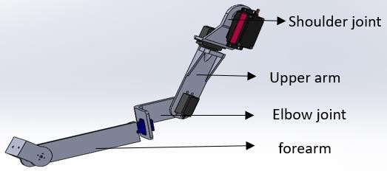 Robot arm
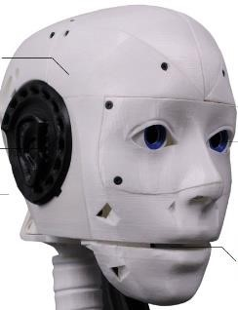
Head of the robot[5]

FRP:
The mid body of the robot is the part that will resemble human’s chest and abdomen. It is manufactured using FRP (Fiber reinforced plastic). FRP is a composite material made of a polymer matrix reinforced with fibers. Fibers are usually glass, carbon, aramid or basalt

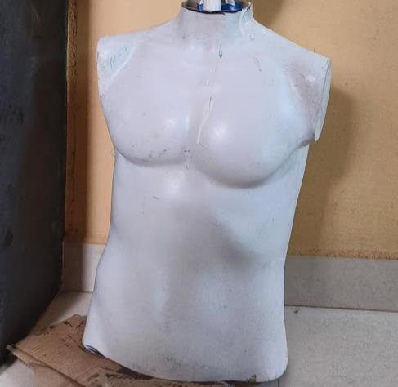
Mid-body of the robot
The fabrication process began with creating a detailed clay sculpture of a human face and body. A mold release agent was then applied to prevent adhesion of subsequent materials. Layers of silicone rubber were applied to the sculpture to form a negative mold, which was then filled with shaped fiberglass cloth. The cloth was saturated with polyester resin and a catalyst, forming a durable composite. After hardening, the composite was removed from the mold, revealing the modeled human shape. Final touches, including painting and sanding, were applied to achieve a realistic and smooth appearance.

Fabrication:
The objective of fabricating the lower body was to provide structural support and stability while accommodating essential components. A trapezoidal prism shape was selected for its efficient internal space and even weight distribution. Mild steel beams were used, and hand tools like drilling and grinding machines were employed for shaping and cutting. Arc welding was initially used to join the beams, followed by MIG welding for its versatility and ability to create strong, durable welds with minimal distortion. The design process began with conceptualizing the shape, followed by forming and welding the beams into the final trapezoidal prism structure.
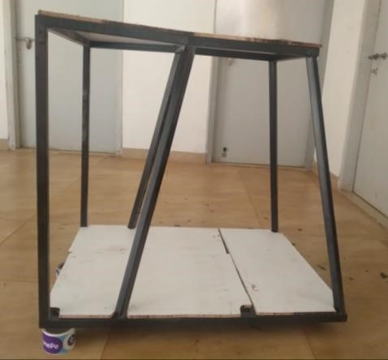
Lower-body
Software Development:
Software development is an essential part of the project to control the robot's motion and functions. As shown below software development has multiple steps involved where the vision and voice development are divided separately. The programming is done for the application development for the motion control, eye movement control and hand movement.
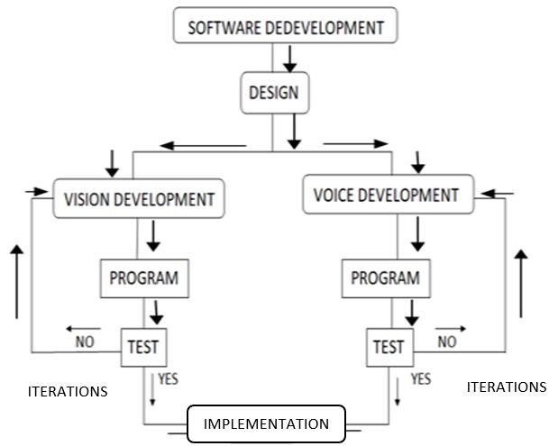

MIT App Inventor
A high-level block-based visual programming language called MIT App Inventor (also known as MIT AI2) was created by Google at first and is currently maintained by the Massachusetts Institute of Technology. It enables novices to develop computer programs for the two operating systems iOS and Android which are currently in beta testing as of September 25, 2023. It is open-source and free. Similar to Scratch, its primary audience consists students learning computer programming.
Project uses design applications that can be tested on Android devices and compiled to operate as Android apps using the web interface, which has a graphical user interface (GUI) that is very similar to Scratch and Star Logo. It makes use of the MIT AI2 Companion smartphone app, which offers live testing and debugging.
App Inventor offers connectivity with a variety of web services, including Firebase and Google Sheets.
Google drew on extensive earlier research in educational computing as well as internal work on online development environments while developing App Inventor. Project has a combined application for eye movement, motion control and hand movement where there is incorporation of multiple layouts that would take the user control to the respective handling page for respective movements.
We use block coding in this platform to program the mobile application as per our need as shown below

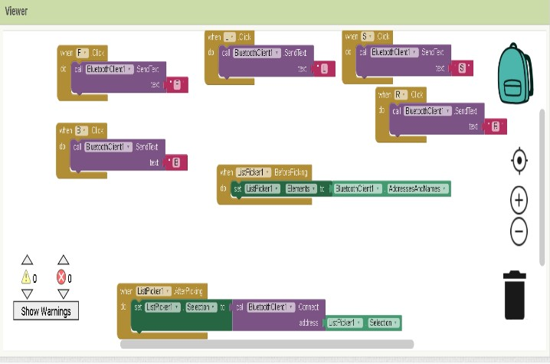
Block coding interface
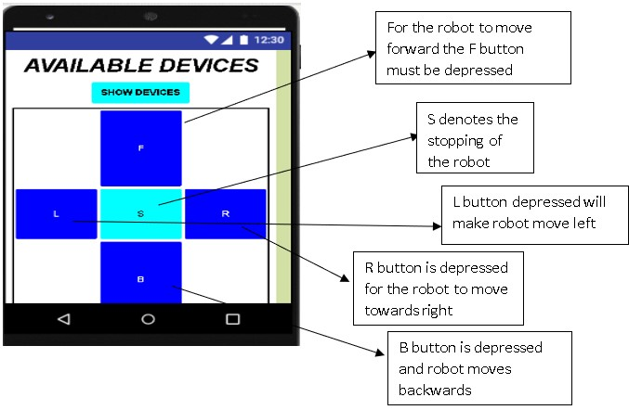
User interface of the program
These process is applied for development of different controls in the robot like base movement, arm movement, eyes movement etc.

Arduino uno:
The Arduino Uno is a microcontroller board which supports the ATmega328P chip.It has 13 digital pins and 6 analog pins and 6 pwm ouput pins .it has 16MHz resonator , a USB affiliation, an influence jack, assocaiate in circcuit system programmuing(ICSP) header and a reset push button on board.
The arduino acts as the brain of the robot by receiving data processing it and then using the information solve the task in hand.
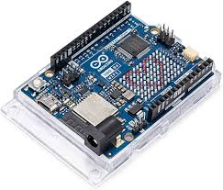

Applications:
Hospitality : Humanoids can perform task like greeting customers taking order and deliverying them to the tables as per the order.They can be used like waiters to carry the orders around. It can even display the menu on the screen and answer questions of the customers.the customers can directly order from the menu and once the meal is ready the humanoid can deliver to the exact table using predefined path for the particular table where the customer are seated. Implementing humanoids can also act as non-contact service to the customers during the pandemic conditions like covid-19.
Education: During the pandmeic these robots can be placed in each department and classroom to constantly monitor the temperature and any related symptoms of the students and any faculty member. These data are stored in cloud and used by differernt departments to monitor student health condtions
Greeting people: Apart from healthcare and educational aspects it can also be used for enteratinment . it can greet guest in functions as it mimics the humans gestures it can greet people by handshake , hi or even a namaste and can convey wishes by giving a boquete and voice to a person.

Conclusion:
The primary goal of this project was to create a multi-domain humanoid robot in least budget possible which is succesfully achieved.The robot can successuly copy the human motions like handshake, hi motion, salute.The face tracking algorithm works good and can track a person in frame to follow his face aroud. The eye motion and neck rotation of the robot is also achievd successfully.The smooth base moment is also achieved successfully.
For future reference we would like to improve on the precison and load capacity of the robot. And also to make the robot completely autonomous with path planning and navigation

References:
- https://www.javatpoint.com/robotics-history
- https://ieeexplore.ieee.org/abstract/document/8030884
- https://ieeexplore.ieee.org/abstract/document/8053274
- https://ijsrmme.com/home/issue/view/article.php?id=IJSRMME20471
- https://inmoov.fr/inmoov-stl-parts-viewer/?bodyparts=Face-and-Jaw&doing_wp_cron=1715783868.4986820220947265625000

